AI LAB EXP – 6

**IMPLEMENTATION OF MINIMAX ALGORITHM FOR AN APPLICATION**

**Tejas Ashok**

**RA1911030010090**

**AIM**

To implement mini-max algorithm as a tic tac toe game using python.

**ALGORITHM**

Mini-max algorithm is a recursive or backtracking algorithm which is used in decision-making and game theory. It provides an optimal move for the player assuming that opponent is also playing optimally. Min-Max algorithm is mostly used for game playing in AI. Such as Chess, Checkers, tic-tac-toe, go, and various tow-players game. This Algorithm computes the minimax decision for the current state.

**CODE**

import random

class TicTacToe(object):

winning_combos = (

[0, 1, 2], [3, 4, 5], [6, 7, 8],

[0, 3, 6], [1, 4, 7], [2, 5, 8],

[0, 4, 8], [2, 4, 6]

)

winners = ('X-win', 'Draw', 'O-win')

def __init__(self, board=[]):

if len(board) == 0:

self.board = [0 for i in range(9)]

else:

self.board = board

def print_board(self):

for i in range(3):

print(

"| " + str(self.board[i * 3]) +

" | " + str(self.board[i * 3 + 1]) +

" | " + str(self.board[i * 3 + 2]) + " |"

)

def check_game_over(self):

if 0 not in [element for element in self.board]:

return True

if self.winner() != 0:

return True

return False

def available_moves(self):

return [index for index, element in enumerate(self.board) if element is 0]

def available_combos(self, player):

return self.available_moves() + self.get_acquired_places(player)

def X_won(self):

return self.winner() == 'X'

def O_won(self):

return self.winner() == 'O'

def is_tie(self):

return self.winner() == 0 and self.check_game_over()

def winner(self):

for player in ('X', 'O'):

positions = self.get_acquired_places(player)

for combo in self.winning_combos:

win = True

for pos in combo:

if pos not in positions:

win = False

if win:

return player

return 0

def get_acquired_places(self, player):

return [index for index, element in enumerate(self.board) if element == player]

def make_move(self, position, player):

self.board[position] = player

def minimax(self, node, player):

if node.check_game_over():

if node.X_won():

return -1

elif node.is_tie():

return 0

elif node.O_won():

return 1

best = 0

for move in node.available_moves():

node.make_move(move, player)

val = self.minimax(node, get_enemy(player))

node.make_move(move, 0)

if player == 'O':

if val > best:

best = val

else:

if val < best:

best = val

return best

def determine(board, player):

'''

Driver function to apply minimax algorithm

'''

a = 0

choices = []

if len(board.available_moves()) == 9:

return 4

for move in board.available_moves():

board.make_move(move, player)

val = board.minimax(board, get_enemy(player))

board.make_move(move, 0)

if val > a:

a = val

choices = [move]

elif val == a:

choices.append(move)

try:

return random.choice(choices)

except IndexError:

return random.choice(board.available_moves())

def get_enemy(player):

if player == 'X':

return 'O'

return 'X'

if __name__ == "__main__":

board = TicTacToe()

print('Board positions are like this: ')

for i in range(3):

print(

"| " + str(i * 3 + 1) +

" | " + str(i * 3 + 2) +

" | " + str(i * 3 + 3) + " |"

)

print('Type in the position number you to make a move on..')

while not board.check_game_over():

player = 'X'

player_move = int(input("Your Move: ")) - 1

if player_move not in board.available_moves():

print('Please check the input!')

continue

board.make_move(player_move, player)

board.print_board()

print()

if board.check_game_over():

break

print('Computer is playing.. ')

player = get_enemy(player)

computer_move = determine(board, player)

board.make_move(computer_move, player)

board.print_board()

if board.winner() != 0:

if board.winner() == 'X':

print("Congratulations you win!")

else:

print('Computer Wins!')

else:

print("Game tied!")

**OUTPUT**

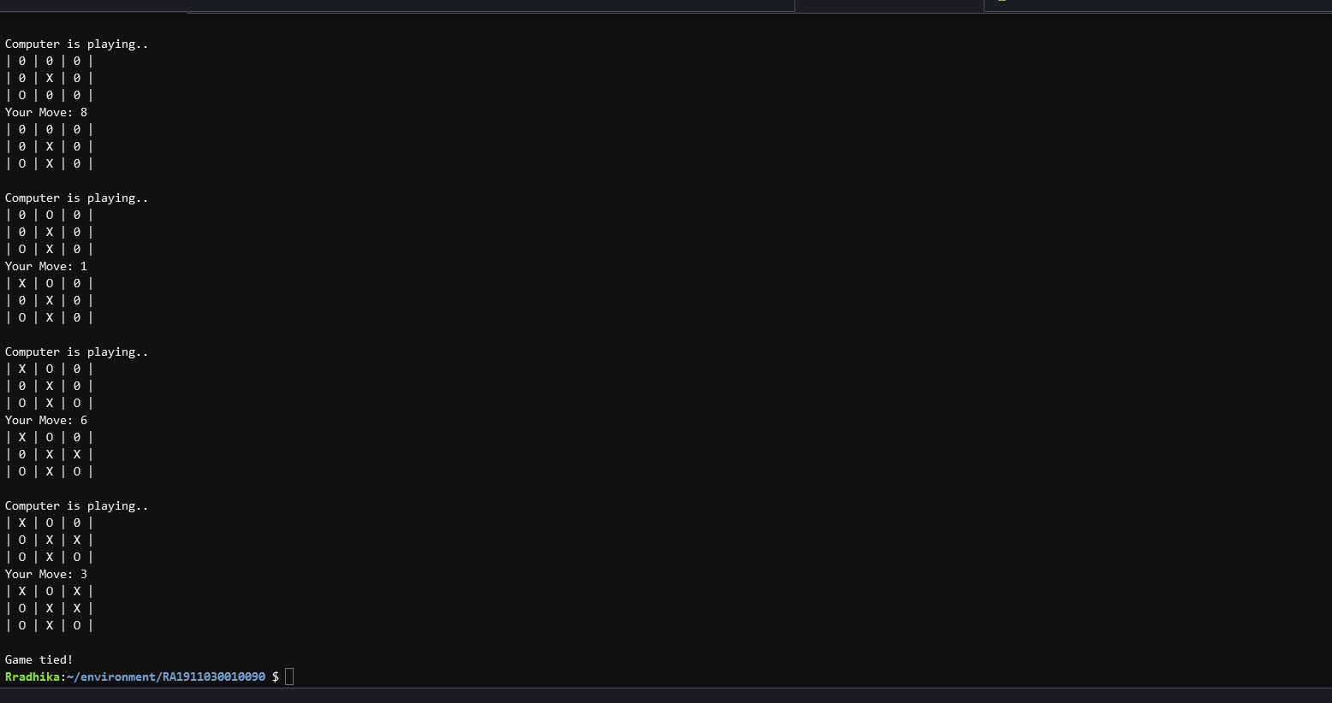

**RESULT**

Mini-Max algorithm has been successfully implemented using python.